A Train Tracker
Introduction:
A train tracking system is a software-based solution designed to monitor and display the real time status of trains. It enables users to access essential information such as current location, schedule, upcoming stations and journey progress through an interactive interface. By utilizing stored data and system time, the application simulates live tracking and helps passengers make informed travel decisions, improving convenience and time management
Java Frame:
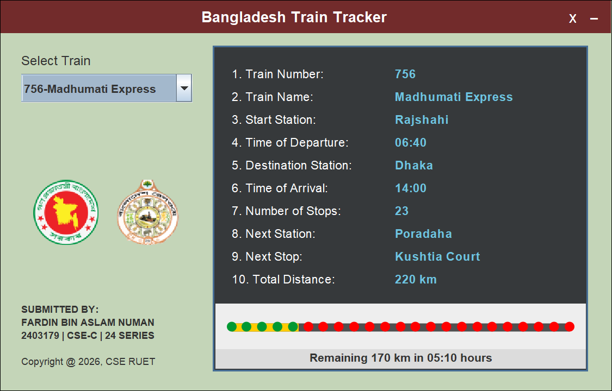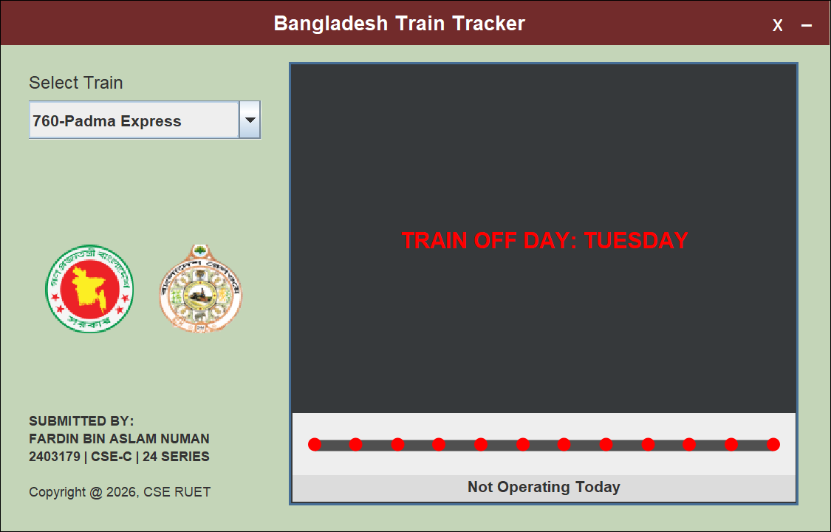

Interface (a): Normal Day
Interface (b): OFF Day
Source Code:
import javax.swing.*;
import javax.swing.border.*;
import java.awt.*;
import java.awt.event.*;
import java.io.*;
import java.time.LocalDate;
import java.time.format.TextStyle;
import java.util.*;
import java.util.List;

// INTERFACE
interface ITrainTracker {
void updateUIContent();
}

// ABSTRACT CLASS
abstract class RailwayEntity {
protected String name;

public RailwayEntity(String name) {
this.name = name;
}

public abstract String getEntityType();

public String getName() {
return name;
}
}

// STATION CLASS
class Station {
String name;
Station(String name) {
this.name = name;
}
}

// TRAIN CLASS
class Train extends RailwayEntity {
String number, name, startStation, departureTime, destinationStation, arrivalTime, offDay, totalDistance;
List<Station> stops;
int passedStops;
String nextStation, nextStop, remainingInfo;

Train(String number, String name, String start, String dep, String dest, String arr,
String dist, String off, int passed, String nextStation, String nextStop, String rem, List<Station> stops) {
super(name);
this.number = number;
this.name = name;
this.startStation = start;
this.departureTime = dep;
this.destinationStation = dest;
this.arrivalTime = arr;
this.totalDistance = dist;
this.offDay = off;
this.passedStops = passed;
this.nextStation = nextStation;
this.nextStop = nextStop;
this.remainingInfo = rem;
this.stops = stops;
}

@Override
public String getEntityType() {
return "Train";
}

public String toFileString() {
return String.format(
"%-3s | %-17s | %-16s | %-5s | %-8s | %-5s | %-6s | %-8s | %-1s | %-8s | %-15s | %-31s | %-2s",
number, name, startStation, departureTime, destinationStation, arrivalTime,
totalDistance, offDay, passedStops, nextStation, nextStop, remainingInfo, stops.size());
}
}

public class Assignment_2403179_CSE1203 extends JFrame implements ITrainTracker {

private final Color MAROON_HEADER = new Color(114, 43, 43);
private final Color SAGE_BG = new Color(196, 213, 184);
private final Color DARK_PANEL = new Color(54, 57, 59);
private final Color VALUE_CYAN = new Color(110, 197, 226);
private final Color BORDER_BLUE = new Color(70, 110, 150);

private JComboBox<String> trainCombo;
private JLabel remainingLabel, logoLabel1, logoLabel2;
private JPanel dataGrid;
private TrackPainter trackPainter;
private Map<String, Train> trainMap;
private int pX, pY;
private final String DATA_FILE = "train-data.txt";

public Assignment_2403179_CSE1203() {
setUndecorated(true);
setSize(750, 480);
setDefaultCloseOperation(EXIT_ON_CLOSE);
setLocationRelativeTo(null);

initializeData();

JPanel mainWrapper = new JPanel(new BorderLayout());
mainWrapper.setBackground(SAGE_BG);
mainWrapper.setBorder(new LineBorder(Color.BLACK, 1));
JPanel header = new JPanel(new BorderLayout());
header.setBackground(MAROON_HEADER);
header.setPreferredSize(new Dimension(0, 40));
header.addMouseListener(new MouseAdapter() {
public void mousePressed(MouseEvent me) {
pX = me.getX();
pY = me.getY();
}
});
header.addMouseMotionListener(new MouseAdapter() {
public void mouseDragged(MouseEvent me) {
setLocation(getLocation().x + me.getX() - pX, getLocation().y + me.getY() - pY);
}
});

JLabel title = new JLabel(" Bangladesh Train Tracker", SwingConstants.CENTER);
title.setForeground(Color.WHITE);
title.setFont(new Font("Arial", Font.BOLD, 18));
header.add(title, BorderLayout.CENTER);

JPanel btnPanel = new JPanel(new FlowLayout(FlowLayout.RIGHT, 15, 5));
btnPanel.setOpaque(false);

JLabel minBtn = new JLabel("-", SwingConstants.CENTER);
minBtn.setForeground(Color.WHITE);
minBtn.setFont(new Font("Monospaced", Font.BOLD, 22));
minBtn.setCursor(new Cursor(Cursor.HAND_CURSOR));
minBtn.addMouseListener(new MouseAdapter() {
public void mouseClicked(MouseEvent e) {
setState(Frame.ICONIFIED);
}
});

JLabel clsBtn = new JLabel("x", SwingConstants.CENTER);
clsBtn.setForeground(Color.WHITE);
clsBtn.setFont(new Font("Arial", Font.PLAIN, 20));
clsBtn.setCursor(new Cursor(Cursor.HAND_CURSOR));
clsBtn.addMouseListener(new MouseAdapter() {
public void mouseClicked(MouseEvent e) {
System.exit(0);
}
});

btnPanel.add(clsBtn);
btnPanel.add(minBtn);
header.add(btnPanel, BorderLayout.EAST);

JPanel content = new JPanel(null);
content.setOpaque(false);

JLabel selectLabel = new JLabel("Select Train");
selectLabel.setBounds(25, 20, 150, 25);
selectLabel.setFont(new Font("SansSerif", Font.PLAIN, 16));
content.add(selectLabel);

trainCombo = new JComboBox<>(
new String[] { "756-Madhumati Express", "792-Banalata Express", "754-Silkcity Express",
"760-Padma Express" });
trainCombo.setBounds(25, 50, 210, 35);
trainCombo.setFont(new Font("SansSerif", Font.BOLD, 14));
trainCombo.addActionListener(e -> updateUIContent());
content.add(trainCombo);

logoLabel1 = new JLabel();
logoLabel1.setBounds(40, 180, 80, 80);
setScaledImage(logoLabel1, "govtLogo.png", 80);
content.add(logoLabel1);

logoLabel2 = new JLabel();
logoLabel2.setBounds(140, 180, 80, 80);
setScaledImage(logoLabel2, "railwayLogo.png", 80);
content.add(logoLabel2);

JLabel copy = new JLabel(
"<html><b>SUBMITTED BY:<br>FARDIN BIN ASLAM NUMAN<br>2403179 | CSE-C | 24 SERIES</b><br><br>Copyright @ 2026, CSE RUET</html>");

copy.setBounds(25, 330, 200, 80);
copy.setFont(new Font("SansSerif", Font.PLAIN, 12));
content.add(copy);

JPanel infoPanel = new JPanel(new BorderLayout());
infoPanel.setBounds(260, 15, 460, 400);
infoPanel.setBackground(DARK_PANEL);
infoPanel.setBorder(new LineBorder(BORDER_BLUE, 3));

dataGrid = new JPanel(new GridBagLayout());
dataGrid.setOpaque(false);
infoPanel.add(dataGrid, BorderLayout.CENTER);

JPanel bottom = new JPanel(new BorderLayout());
bottom.setBackground(new Color(220, 220, 220));
bottom.setPreferredSize(new Dimension(0, 80));

trackPainter = new TrackPainter();
remainingLabel = new JLabel("", SwingConstants.CENTER);
remainingLabel.setFont(new Font("SansSerif", Font.BOLD, 14));
remainingLabel.setBorder(new EmptyBorder(0, 0, 5, 0));

bottom.add(trackPainter, BorderLayout.CENTER);
bottom.add(remainingLabel, BorderLayout.SOUTH);
infoPanel.add(bottom, BorderLayout.SOUTH);
content.add(infoPanel);

mainWrapper.add(header, BorderLayout.NORTH);
mainWrapper.add(content, BorderLayout.CENTER);
add(mainWrapper);

updateUIContent();
}

private void setScaledImage(JLabel label, String path, int size) {
try {
ImageIcon icon = new ImageIcon(path);
Image img = icon.getImage().getScaledInstance(size, size, Image.SCALE_SMOOTH);
label.setIcon(new ImageIcon(img));
} catch (Exception e) {
label.setText("No Logo");
}
}

private void initializeData() {
trainMap = new HashMap<>();
File file = new File(DATA_FILE);

if (file.exists()) {
try (BufferedReader reader = new BufferedReader(new FileReader(file))) {
reader.readLine();
reader.readLine();
String line;
while ((line = reader.readLine()) != null) {
String[] d = line.split("\\s*\\|\\s*");
if (d.length < 13)
continue;
List<Station> stops = new ArrayList<>();
int stopCount = Integer.parseInt(d[12].trim());
for (int i = 0; i < stopCount; i++)
stops.add(new Station("S"));
Train t = new Train(d[0].trim(), d[1].trim(), d[2].trim(), d[3].trim(), d[4].trim(), d[5].trim(),
d[6].trim(), d[7].trim(), Integer.parseInt(d[8].trim()), d[9].trim(), d[10].trim(),
d[11].trim(), stops);
trainMap.put(d[0].trim() + "-" + d[1].trim(), t);
}
} catch (Exception e) {
e.printStackTrace();
}
} else {
createDefaultData();
saveToTxtFile();
}
}

private void createDefaultData() {
trainMap = new HashMap<>();

// TRAIN INFORMATIONS FROM https://eticket.railway.gov.bd/ WEBSITE (RAJSHAHI TO DHAKA)
// MADHUMATI EXPRESS
List<Station> s1 = new ArrayList<>();
String[] madhumatiStations = { "Rajshahi", "Ishwardi", "Paksey", "Bheramara", "Mirpur",
"Poradaha", "Kushtia Court", "Kumarkhali", "Khoksha", "Pangsha",
"Kalukhali", "Rajbari", "Pachuria", "Amirabad", "Faridpur",
"Talma", "Pukuria", "Bhanga", "Shibchar", "Padma",
"Mawa", "Sreenagar", "Dhaka" };
for (String station : madhumatiStations)
s1.add(new Station(station));
trainMap.put("756-Madhumati Express",
new Train("756", "Madhumati Express", "Rajshahi", "06:40", "Dhaka", "14:00", "220 km", "Saturday", 5,
"Poradaha", "Kushtia Court", "Remaining 170 km in 05:10 hours", s1));

// BANALATA EXPRESS
List<Station> s2 = new ArrayList<>();
String[] banalataStations = { "Chapainawabganj", "Rajshahi", "Dhaka" };
for (String station : banalataStations)
s2.add(new Station(station));
trainMap.put("792-Banalata Express", new Train("792", "Banalata Express", "Chapainawabganj", "06:00", "Dhaka",
"11:35", "320 km", "Friday", 1, "Rajshahi", "Dhaka", "Remaining 280 km in 04:45 hours", s2));

// SILKCITY EXPRESS
List<Station> s3 = new ArrayList<>();
String[] silkcityStations = { "Rajshahi", "Abdulpur", "Ishwardi", "Chatmohar", "Boral Bridge", "Ullapara",
"Jamtail", "SHM Monsur Ali", "Ibrahimabad",
"Tangail", "Mirzapur", "Joydebpur", "Dhaka" };
for (String station : silkcityStations)
s3.add(new Station(station));
trainMap.put("754-Silkcity Express", new Train("754", "Silkcity Express", "Rajshahi", "07:40", "Dhaka", "13:20",
"220 km", "Sunday", 7, "Ullapara", "Jamtail", "Remaining 126 km in 02:50 hours", s3));

// PADMA EXPRESS
List<Station> s4 = new ArrayList<>();
String[] padmaStations = { "Rajshahi", "Sardah Road", "Abdulpur", "Ishwardi Bypass", "Chatmohar",
"Boral Bridge", "Ullapara", "SHM Monsur Ali", "Ibrahimabad", "Tangail",
"Joydebpur", "Dhaka" };
for (String station : padmaStations)
s4.add(new Station(station));
trainMap.put("760-Padma Express", new Train("760", "Padma Express", "Rajshahi", "16:00", "Dhaka", "21:15",
"220 km", "Tuesday", 5, "Ullapara", "SHM Monsur Ali", "Remaining 145 km in 03:20 hours", s4));

saveToTxtFile();
}

// TO SAVE TRAIN-DATA TO train-data.txt FILE
private void saveToTxtFile() {
try (PrintWriter writer = new PrintWriter(new FileWriter(DATA_FILE))) {

writer.println(
"ID | Name | Start Station | Dep | Dest | Arr | Dist | Off Day | # | Next St. | Next Sp. | Progress Info | Stops");
writer.println(
"---------------------------------------------------------------------------------------------------------------------------------------------------------------------");
for (Train t : trainMap.values()) {
writer.println(t.toFileString());
}
} catch (IOException e) {
e.printStackTrace();
}
}

@Override
public void updateUIContent() {
dataGrid.removeAll();
Train t = trainMap.get((String) trainCombo.getSelectedItem());

// TO EXTRACT DAY FROM THE SYSTEM
String currentDay = LocalDate.now().getDayOfWeek().getDisplayName(TextStyle.FULL, Locale.ENGLISH);

// TO DISPLAY MESSAGE FOR TRAIN OFF DAY
if (currentDay.equalsIgnoreCase(t.offDay)) {
JLabel msg = new JLabel("TRAIN OFF DAY: " + t.offDay.toUpperCase());
msg.setForeground(Color.RED);
msg.setFont(new Font("SansSerif", Font.BOLD, 20));
dataGrid.add(msg);
remainingLabel.setText("Not Operating Today");
trackPainter.setStats(0, t.stops.size());
} else {
String[] vals = { t.number, t.name, t.startStation, t.departureTime, t.destinationStation, t.arrivalTime,
String.valueOf(t.stops.size()), t.nextStation, t.nextStop, t.totalDistance };
String[] keys = { "1. Train Number:", "2. Train Name:", "3. Start Station:", "4. Time of Departure:",
"5. Destination Station:", "6. Time of Arrival:", "7. Number of Stops:", "8. Next Station:",
"9. Next Stop:", "10. Total Distance:" };

GridBagConstraints gbc = new GridBagConstraints();
gbc.fill = GridBagConstraints.HORIZONTAL;
gbc.insets = new Insets(3, 20, 3, 10);

for (int i = 0; i < keys.length; i++) {
JLabel k = new JLabel(keys[i]);
k.setForeground(Color.WHITE);
k.setFont(new Font("SansSerif", Font.PLAIN, 15));
k.setPreferredSize(new Dimension(170, 22));
gbc.gridx = 0;
gbc.gridy = i;
gbc.weightx = 0;
dataGrid.add(k, gbc);

JLabel v = new JLabel(vals[i]);
v.setForeground(VALUE_CYAN);
v.setFont(new Font("SansSerif", Font.BOLD, 15));
gbc.gridx = 1;
gbc.weightx = 1.0;
dataGrid.add(v, gbc);
}
remainingLabel.setText(t.remainingInfo);
trackPainter.setStats(t.passedStops, t.stops.size());
}
dataGrid.revalidate();
dataGrid.repaint();
}

class TrackPainter extends JPanel {
private int p, tt;

public void setStats(int p, int tt) {
this.p = p;
this.tt = tt;
this.repaint();
}

@Override
protected void paintComponent(Graphics g) {
super.paintComponent(g);
if (tt <= 0)
return;
Graphics2D g2 = (Graphics2D) g;
g2.setRenderingHint(RenderingHints.KEY_ANTIALIASING, RenderingHints.VALUE_ANTIALIAS_ON);
int y = getHeight() / 2 - 4, xS = 20, xE = getWidth() - 20, tW = xE - xS;
g2.setColor(new Color(80, 80, 80));
g2.fillRect(xS, y, tW, 10);
double ratio = (tt > 1) ? (double) (p - 0.6) / (tt - 1) : 0;
g2.setColor(new Color(255, 204, 0));
g2.fillRect(xS, y, (int) (tW * Math.min(1.0, ratio)), 10);
for (int i = 0; i < tt; i++) {
int dX = (tt > 1) ? xS + (i * tW / (tt - 1)) : xS + (tW / 2);
g2.setColor(i < p ? new Color(0, 153, 51) : Color.RED);
g2.fillOval(dX - 6, y - 2, 12, 12);
}
}
}

public static void main(String[] args) {
SwingUtilities.invokeLater(() -> new Assignment_2403179_CSE1203().setVisible(true));
}
}

Train Data:
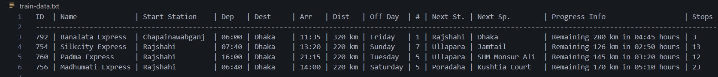
Conclusion:
The Train Tracker application demonstrates how OOPS concepts can be applied to build a practical and user friendly system. Through the use of classes, interfaces, file handling and GUI components, the program efficiently manages train data and presents it in a structured format. This project not only enhances understanding of Java Swing and OOP principles but also reflects how real world transportation systems can be digitally modeled to improve user experience and operational efficiency

